

# mypractice Claims Capture with Collections

## quick reference guide

Brought to you by



Copyright © 2015 Healthbridge (Pty) Ltd

This document is the sole and exclusive intellectual property of Healthbridge (Pty) Ltd. and may not

be used or adapted for any purpose whatsoever without the prior written consent of Healthbridge

(Pty) Ltd.

### Welcome

Go to **www.mypractice.co.za** to get started.

You will need a **username** and **password** to access **my**practice.

You can write your login details below; keep them safe and do not share your password.

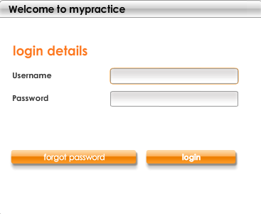

This guide is split by module – **capture** functionality is covered in the first section, **collections** in the second.

### Contents

Welcome 1

Contents 3

What is mypractice with Claims Capture? 1

Getting started – what is new on each tab? 2

The home tab 2

The patient tab 3

The claim tab 4

The reconcile tab 5

The admin tab 5

Adding users 6

Adding doctors 7

Changing network settings 8

Workflow – capturing patients 10

Adding a main member (account holder) 11

Searching for patients 12

Basic search 12

Advanced search 13

Adding dependants (patients) 14

Editing patients 16

Workflow – capturing claims 18

Creating templates 20

Editing templates 21

Creating claims (GPs, Auxiliaries & Specialists) 22

Creating claims (Optometrists) 24

Script details 25

Claim details 26

Creating PPN claims 27

For cash patients only (all specialities) 29

Creating claims (Compensation Fund – IOD) 30

The patient account setup for IOD claims 30

Creating the claim 31

Process to submit the required supporting documentation 33

Creating a claim from a template (Specific to an Optom) 35

For cash patients only 35

Claim statuses and definitions 36

The claims to do list 38

Search claims 39

View claim details 41

Remittance tab 43

Fix and resubmit a claim 44

Reverse a claim 45

Discovery Health claim reversals 45

Manual claim reversals 46

Age analysis of claims report 47

What is mypractice with Collections? 49

Getting started – what is new on each tab? 51

The home tab 51

The patient tab 52

The claim tab 53

The reconcile tab 53

The collect tab 54

The admin tab 54

Confirm company details 55

Customise collections settings 56

Your business process – best practice guidelines 58

Workflow – can I invoice this claim? 59

Creating an invoice 61

What does the invoice look like? 62

a. Create invoice 64

b. Create invoice and send 65

c. Create invoice and print 66

d. Create invoice, print and send 67

The collect to do list 68

Taking action on an invoice 69

Search invoices 70

View an invoice 71

Pay@ payments 73

Process flow 73

Search payments 74

View a payment 75

Reversing payments 76

Capture medical aid payment from paper RA’s 78

Reports 80

Working at a patient level 81

Account - financial summary 82

Account - search invoices 83

Account - search payments 84

Account – SMSs 85

Creating a new SMS 86

Practice management features 87

The reconcile to do list 87

Remittance advices from the medical aid 88

Reports 90

Support 91



# Claims Capture

### What is mypractice with Claims Capture?

We strive to continually improve your experience with our products and services.

We have recognised that one of our initial claims products, **Healthsuite 2.9**, has clients submitting their claims in one system and following up in another.

Our latest **my**practice release has moved the functionality of **Healthsuite 2.9** into the existing **my**practice. You can now create and submit claims, as well as track and manage them from **my**practice.

**my**practice with **Claims Capture** will assist in streamlining your processes for greater administrative efficiency.

**note:** If you are using only Claims Capture, you may find that screenshots in this guide do not appear exactly alike to your product, this is because they are a combination of Claims Capture and Collections. Please contact your client specialist if you would like to know more about **my**practice Claims Capture with Collections.

### Getting started – what is new on each tab?

#### The home tab



* Shows your **performance snapshot**
* Provideseasy access to the tools that manage your practice
* DisplaysHealthbridge communications

There is a new **quick link** to create a new claim.

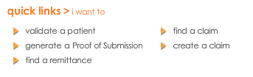

#### The patient tab



* A patient-centric view i.e. looking at one account at a time
* All patient account details, membership details, dependants and contact information is managed here
* A complete view of claims and payments, actions required, and account information at a patient level

For **existing patients**, you need to search for the account you want to work with.

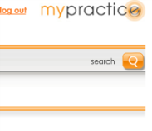

For **new patients** you need to complete their details and save the account.

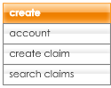

You are able to **create claims** under the **patient** tab by selecting either a **new** claim or a claim **from template**.

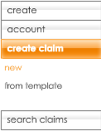

You can also view an SMS history, showing any SMS reminders sent from **my**practice, and add **notes** toa specific patient account

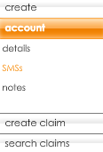

**new**

#### The claim tab



* A practice-centric view i.e. looking at all the practice’s claims, from various patients
* A complete view of claims and payments, actions required, account information
* Allows you to work on a specific task, rather than a specific patient

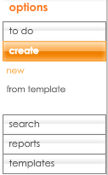You are able to create claims under the **claim** tab by selecting either a **new** claim or a claim **from template**.

You can reverse claims electronically for Discovery Health and manually for all other medical aids.



#### The reconcile tab



* A complete view of all your remittance advices received
* The place where your RAs are stored for 6 months

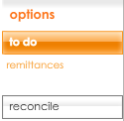

#### The admin tab



You are now required to create doctors/providers on **my**practice, as this information is mandatory for medical aids to process claims.

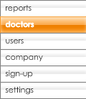

### Adding users

1. Select the **admin** tab



1. Select **users** from the **options** menu

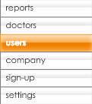

1. Click on **new user**



1. Complete the **user details** and **login details.** Pay careful attention to the password criteria

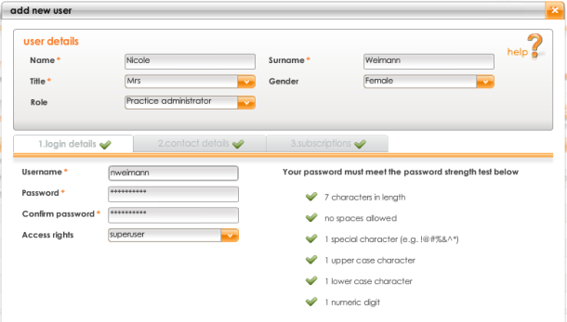

1. Click on **next**
2. Complete the user’s **contact details**



1. Click on **next**
2. Complete the user’s **subscriptions**



1. Click on **save**

**note**: all mandatory fields must be completed; if they are not the fields will be highlighted red to assist you



### Adding doctors

1. Select the **admin** tab



1. Select **doctors** from the **options** menu



1. Click on **new doctor**



1. Complete the **doctor details**

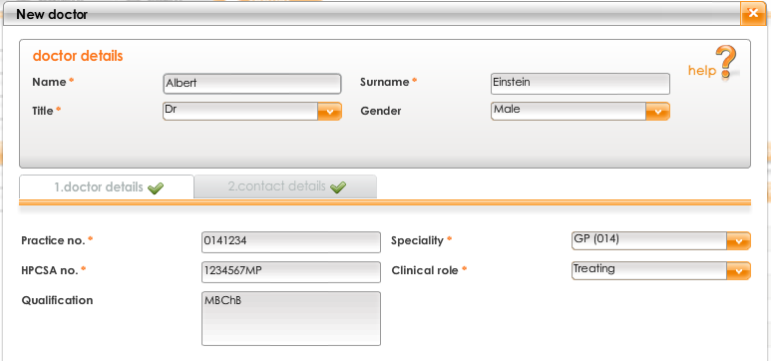

1. Click on **next**
2. Complete the doctor’s **contact details**



1. Click on **save**

**note**: all mandatory fields must be completed; if they are not the fields will be highlighted red to assist you



### Changing network settings

Doctors that are registered on a network can ensure that the right prices are drawn into **my**practice when capturing claims by changing their network settings. This can be achieved for the following medical schemes:

* Anglo Vaal
* Bankmed
* BMW
* Camaf
* Compcare
* Discovery
* Gems
* Liberty
* Malcor
* Polmed
* Retail Medical Aid
* Tiger Brands
* Tsogo Sun Group
* University of KZN

1. Select the **admin** tab



1. Select **settings** from the **options** menu.
2. Select **network pricing** from the **settings** menu

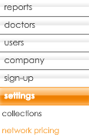

1. Click on **new network setting**



1. Complete the **new network setting** details

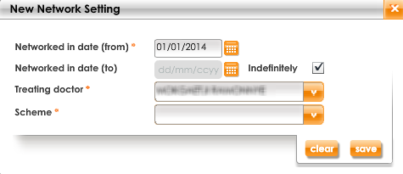

1. Click on **save**
2. You can edit the network setting by selecting the item you want to edit and clicking **edit network setting**



1. Click on **save**
2. To remove a network setting, select the item you want to remove and click **delete network setting**



1. Click on **yes**

### Workflow – capturing patients

This workflow will guide you as to what steps to take when adding a patient.

Feel free to remove this page from the guide and put it near your PC, easily visible, to help you with the process while it is still new.

Questions to ask are orange, and the steps in **my**practice are grey.

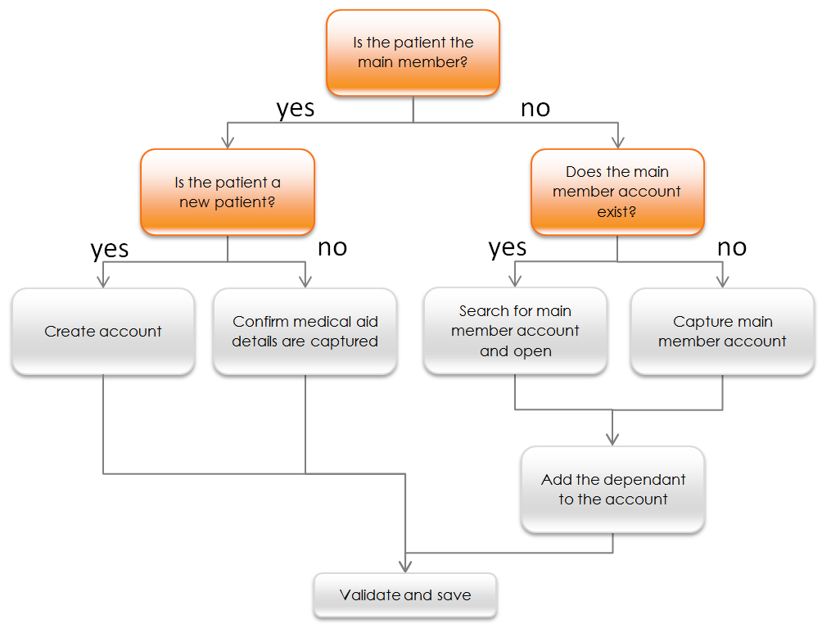

### Adding a main member (account holder)

1. Select the **patient** tab



1. Select **create** from the **options** menu



1. Complete the patient’s **personal** information

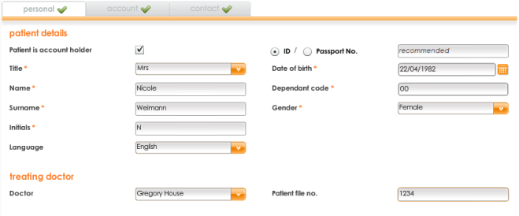

1. Click on **next**
2. Complete the patient’s **account** information



1. Should the patient be a cash patient, tick **cash account**

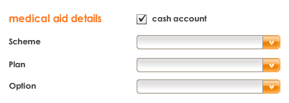

1. Click on **next**
2. Complete the patient’s **contact** information



1. Click on **validate and save**



**note**: all mandatory fields must be completed; if they are not the fields will be highlighted red to assist you

### Searching for patients

#### Basic search

1. Select the **patient** tab  
   
2. Click on **account** in the options menu

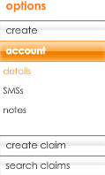

1. The patient search dialog box opens. Enter at least 3 characters to display possible matches

**note**: this search finds matches using name, surname or account number. Typing “Van” displays “**Van**essa” and “**van** der Merwe”. Enter more characters to refine results.

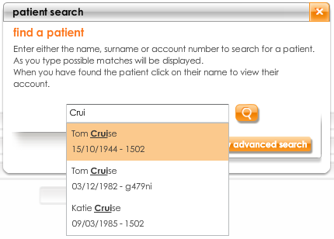

1. Select the patient by clicking on their name

**note**: Click on **show advanced search** if you need alternative search criteria

#### Advanced search

1. Click on **show advanced search** if you need alternative criteria



1. Select the criteria to search by (additional options are **ID** and **member** **no**.)
2. Enter 2 or more characters and click on **search**

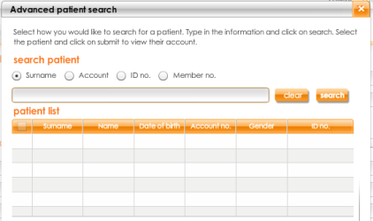

1. Select the patient and click on **submit**



### Adding dependants (patients)

1. Select the **patient** tab  
   
2. Click on **account** in the options menu



1. Search for the main members patient account



1. Click on **add dependant**



1. Complete the patient’s **personal** information

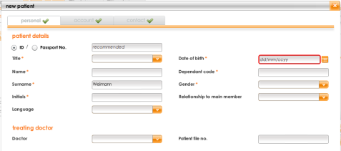

1. Click on **next**
2. Complete the patient’s **account** information



1. Click on **next**
2. Complete the patient’s **contact** information



1. Click on **validate and save**

**note**: all mandatory fields must be completed; if they are not the fields will be highlighted red to assist you.



### Editing patients

1. Select the **patient** tab  
   
2. Click on **account** in the options menu



1. Search for the patient account you want to edit



1. Either click on **edit account** to edit main member **or** select the dependant and click on **edit dependant**

OR

 

1. Update the patient’s **personal** information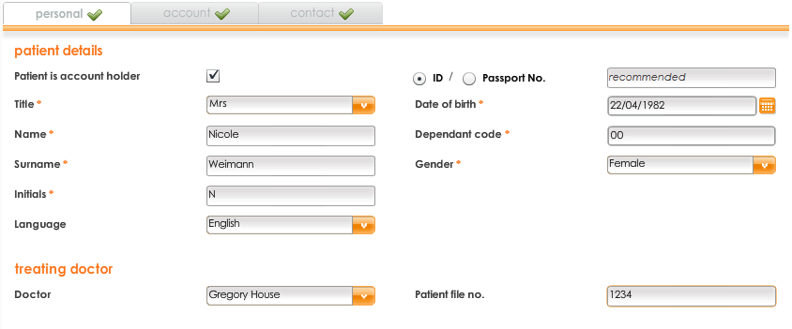
2. Click on **next**
3. Update the patient’s **account** information



1. Click on **next**
2. Update the patient’s **contact** information



1. Note that you have an option to change a dependant into a main member by clicking **change to main member**
2. Click on **validate and save**

**note**: all mandatory fields must be completed; if they are not the fields will be highlighted red to assist you.



**Note:** You can remove an existing patient account or dependant by clicking on **delete dependant** or

**delete account** and then clicking **yes**OR

**Note:** You can validate a patient account at any time by clicking on the **patient validation** button

under the main member or dependant



### Workflow – capturing claims

This workflow will guide you as to what steps to take when capturing claims.

Feel free to remove this page from the guide and put it near your PC, easily visible, to help you with the process while it is still new.

Questions to ask are orange, and the steps in **my**practice are grey.

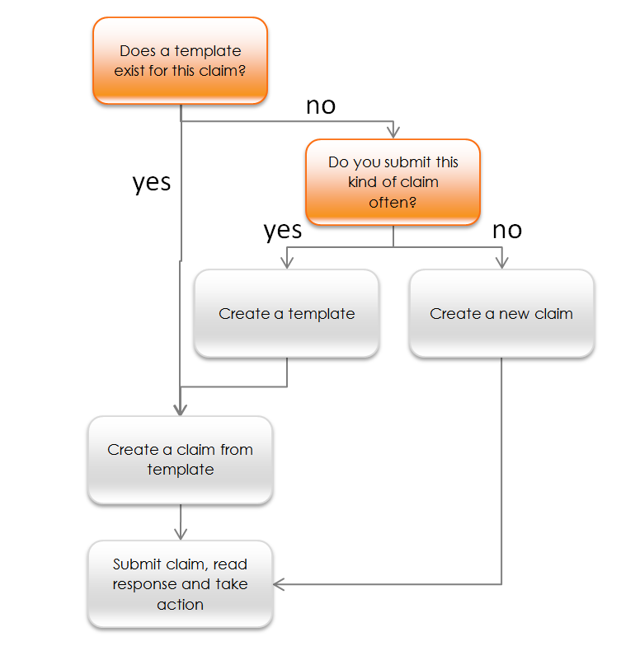

### Creating templates

1. Select the **claim** tab



1. Select **templates** from the **options** menu

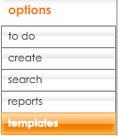

1. Click on **new template**



1. Complete the template, capturing all lines and other necessary information

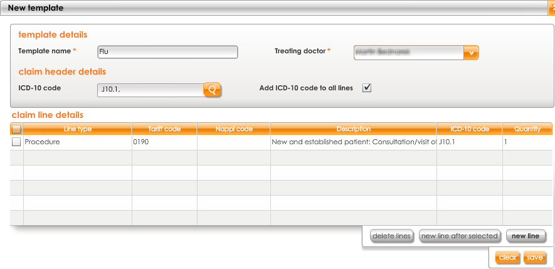

1. Click on **save**



### Editing templates

1. Select the **claim** tab



1. Select **templates** from the **options** menu



1. Select the template that you want to edit
2. Click on **edit template**



1. Update the template



1. Click on **save**



**Note:** You can also remove a template by selecting the template you want removed and clicking **delete template** then **yes**



### Creating claims (GPs, Auxiliaries & Specialists)

1. Select the **claim** tab



1. Select **create** from the **options** menu
2. Select **new** from the **create** menu

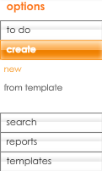

1. Select the **patient**



1. If the patient is a cash patient, it will be visible when selected (red dot and indicator)

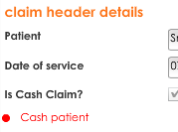

1. To edit the patient account before capturing the claim click on **edit patient**  
   
2. Complete the claim, capturing all lines and other necessary information
3. Tick **add ICD-10 code to all lines** if applicable

**note**: If you selected a treating doctor for the patient, or if there is only one treating doctor, it will be automatically populated.

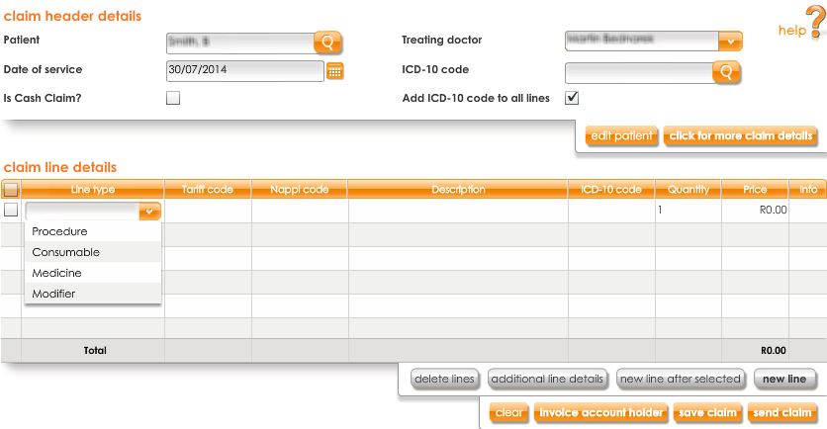

1. You can complete additional header and line level information by clicking on **click for more claim**

OR

**details** or **additional line details**

 

1. To change the **price** or **quantity** on a line, click on the value and edit it



1. Click on **new line** to add additional lines



1. To delete a line, select the line under the claim line details and click on **delete lines**



1. When finished capturing claim header and line details, click on **send** **claim.** Alternatively click on

**save claim** to send it later.

 OR 

**note**: If the patient is a **cash patient**, the button will read **save** instead and claim status will read **cash claim**



### Creating claims (Optometrists)

1. Select the **claim** tab



1. Select **create** from the **options** menu
2. Select **new** from the **create** menu

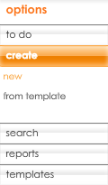

1. Select the **patient**



1. If the patient is a cash patient, it will be visible when selected (red dot and indicator)



1. Complete the claim, capturing all lines and other necessary information
2. Tick **add ICD-10 code to all lines** if applicable

**note**: If you selected a treating doctor for the patient when creating their account, or if there is only one treating doctor, it will be automatically populated.

1. You can complete additional header and line level information by clicking on **click for more claim details** or **additional line details**

OR

 

#### Script details

1. By default the **script details** tab is displayed first  
   
2. Click on **new script** to add additional lines



1. Capture the script details for the first eye, selecting **eye**, **lens** and **status** fromthe drop down lists

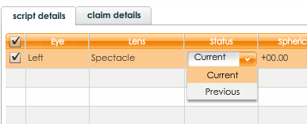

1. Update the values for **spherical**, **cylindrical**, **axis**, **add** and **prism**, by clicking on the value and typing in a new one

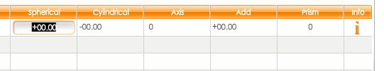

1. Click on the **info** icon to capture additional script details



1. Capture additional script details, if applicable

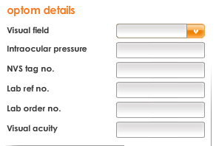

1. Click on **save**



1. To delete a script, select the incorrect eye and click on **delete script**



#### Claim details

1. Click on the **claim details** tab



1. Complete the claim line information, capturing all lines and other necessary information

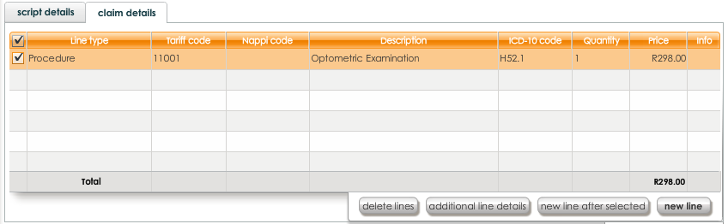

1. You can complete line level information by clicking on **additional line details**



1. To change the **price** or **quantity** on a line, click on the value and edit it



1. Click on **new line** to add additional lines



1. To delete a line, select the line under the claim line details and click on delete line



1. a) When finished capturing claim header and line details, click on **send** **claim** to send now



b) To save the claim (either if cash patient or to review claim and send later) click on **save claim**



1. a) If you sent the claim now, the status will update once a response is received from the funder   
   b) If you saved the claim, the status will be **saved** and further action can be taken from the **to do list**

You will be asked if you would like to capture another claim, click on **yes** to do so, or **no** to go to the **search claims** view (**patient** tab) or **to do list** (**claim** tab)

#### Creating PPN claims

1. Select the **claim** tab



1. Select **create** from the **options** menu
2. Select **new** from the **create** menu

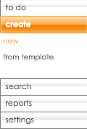

1. Select the **patient**



**note**: at this point the system will automatically assist to generate a PPN claim, based on the patient’s medical aid

1. Complete the **claim header details**
2. Tick **add ICD-10 code to all lines** if applicable

**note**: If you selected a treating doctor for the patient, or if there is only one treating doctor, it will be automatically populated.

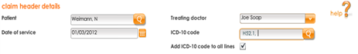

1. You can complete additional header and line level information by clicking on **click for more claim details**



**Script details**

1. By default the **script details** tab is displayed first  
   
2. Click on **add script** to add additional lines



1. Capture the script details for the first eye, selecting **eye**, **lens** and **status** fromthe drop down lists



1. Update the values for **spherical**, **cylindrical**, **axis**, **add** and **prism**, by clicking on the value and typing in a new one



1. Click on the **info** icon to capture additional script details. **This is compulsory for PPN claims**



1. Capture additional script details



1. Click on **save**



1. To delete a script, select the incorrect eye and click on **delete script**



**Claim details**

1. Click on the **claim details** tab



1. The claim lines required for PPN have been created, using the additional script details you captured

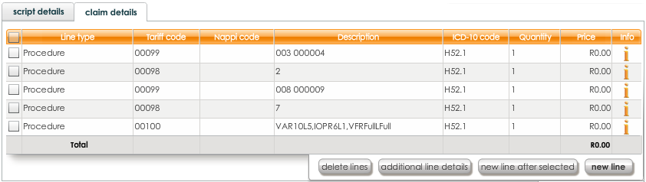

1. The lines have already been linked to the relevant eyes, you can confirm by clicking on **additional line details**



1. Click on **new line** to add the balance of lines that make up the claim



1. To delete a line, select the line under the claim line details and click on delete line



1. To change the **price** or **quantity** on a line, click on the value and edit it



1. When finished capturing claim header and line details, click on **send** **claim**



### For cash patients only (all specialities)

Once you click on **save**, you will have the option to send an invoice now or later

* If you send now, you will continue with creating an invoice
* If you send later, the claim will be moved to your **claim** **to do** list to take action later

### Creating claims (Compensation Fund – IOD)

The **Compensation Fund for Occupational Injuries or Diseases (COID)** reimburses claims for injuries, diseases or death which result from an Injury On Duty, hence IOD claim. Claims can be submitted for employees that have sustained injuries or contracted diseases while working or training.

Claims are paid if they are submitted by following the correct procedures after the injury, diagnosis of disease or death. Complete and correct supporting documentation must be provided on the **Umehluko website**.

We recommend that you create a new account for an IOD claim as you must select **Compensation Fund** as the scheme for the patient. If you edit the existing medical aid account for the patient, you run the risk of forgetting to change it back prior to submitting a regular claim.

#### The patient account setup for IOD claims

A new account needs to be created for both new and existing patient to reflect the compensation fund as medical aid.

1. Select the **patient** tab



1. Select **create** from the **options** menu



1. Complete the patient’s **personal** information
2. Click on **next**
3. Complete the following **account** details

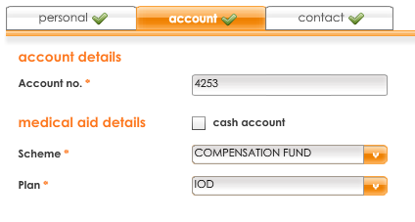

1. Click on **next**
2. Complete the **contact** details
3. Click on **validate and save**

#### Creating the claim

The claim will be created as per the normal process, but with one exception:

**Mandatory COID codes need to be captured as line items**

|  |  |
| --- | --- |
| ****Code – Description**** | ****Details**** |
| **COID1** - Claim number | Provided by the employer (the employer is sent this reference number after they notify the fund of the IOD) |
| **COID2** - Date of Incident | Format = yyyymmdd  Please do not deviate from this format |
| **COID3** - Employer Registration Number | A registration number provided by COID during each employers initial registration with the fund |
| **COID4**  - Employer Trade Name | The employer’s registered trading name |
| **COID5** - Patient ID number | The patient’s ID number  Please ensure that it is captured correctly and in full to avoid unnecessary processing delays |

1. Select the **claim** tab



1. Select **create** from the **options** menu
2. Select **new** from the **create** menu



1. Select the **patient**



1. Complete the **claim header details**
2. Tick **add ICD-10 code to all lines** if applicable
3. Complete the claim by adding 5 claim lines, with the following tariff codes

**note:**  each tariff code will provide information on what needs to be added in the description field

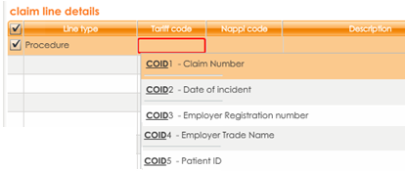

1. Complete the description field with the relevant information

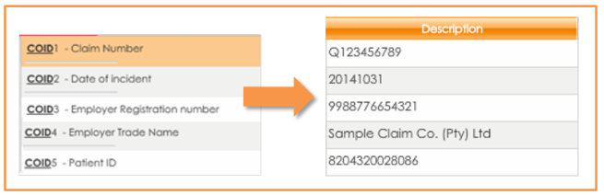

1. Do not edit the quantity or price for these lines

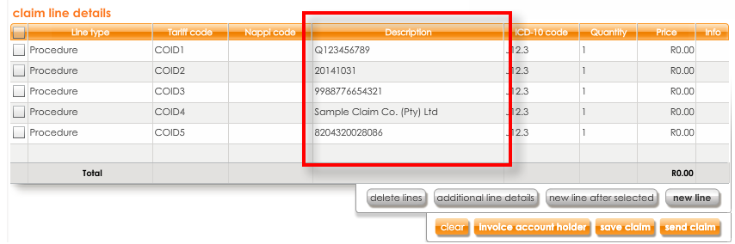

1. Capture the balance of the claims as you normally would, here you can adjust the quantity and price if necessary
2. Once all the lines have been captured, click on **send claim**



1. Upload supporting documentation and track the claim’s progress using the **Umehluko website**

The following documentation needs to be uploaded for all injury on duty cases:

* Original scripts for all pharmacy claims
* Referral notes from the treating practitioner for all other medical service provider’s accounts

#### Process to submit the required supporting documentation

The practice needs to be registered on the **Umehluko portal** at the Compensation Fund in order to submit all supporting documents.

1. To register, send an email to [**ccms@labour.gov.za**](mailto:ccms@labour.gov.za)
2. You will receive a username and password
3. Log onto **https://umehluko.labour.gov.za**  and enter the username and password received

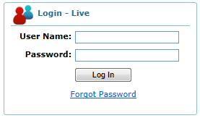

1. Follow the instructions to upload and submit the supporting documents

Creating a claim from a template

1. Select the **claim** tab



1. Select **create** from the **options** menu
2. Select **from template** from the **create** menu

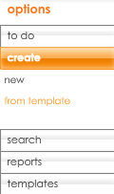

1. Select the template
2. Click on **create claim**



1. Select the **patient**



1. Patient and claim information have been merged to form a claim, ready to send to the medical aid

**note**: If you selected a treating doctor for the patient, or if there is only one treating doctor, it will be automatically populated.

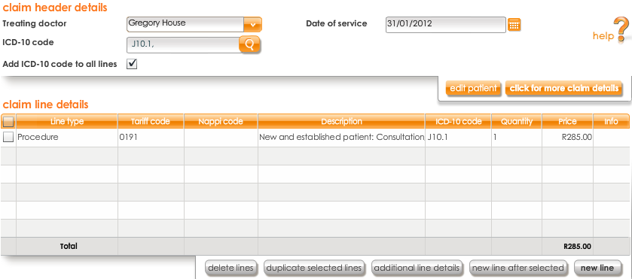

1. Click on **send claim**



**note**: If the patient is a **cash patient**, the button will read **save** instead and claim status will read **cash claim**

#### Creating a claim from a template (Specific to an Optom)

When you create an optom template, **only the claim details are pre-populated**.

Please capture the script details for the patient, and when you move over to the **claim** tab you will notice that all line items from the template are there.

Please link the scripts to the appropriate claim lines and send.

#### For cash patients only

Once you click on **save** to invoice a cash payment, you will have the option to send an invoice now or later

* If you send now, you will continue with creating an invoice
* If you send later, the claim will be moved to your **to do** list to take action later

### Claim statuses and definitions

When claims are submitted the status of the claim will change to one of the following:

|  |  |
| --- | --- |
| Awaiting response | Your claim has left your computer and reached Healthbridge, but there has not yet been response from medical aid. The status will update when a response is available. |
| Awaiting reversal | Your **Claim Reversal** has left your computer and reached Healthbridge, but there has not been a response from the medical aid. The status will update when a response is available |
| Cash claim | This is a cash claim and will therefore not be sent to the medical aid |
| Paid by Medical Aid | The medical aid payment has been manually captured. The medical aid paid the entire claimed amount |
| Part Paid by Medical Aid | The medical aid payment has been manually captured. The medical aid only paid a portion of he claimed amount |
| Part Processed by Medical Aid | Medscheme has processed some of your claim lines. Others are still awaiting processing. Please check the remittance for the final outcome |
| Part Rejected | The medical aid has rejected one or more of the claim lines of you claim. Read the response to find out why and take the appropriate action |
| Processed by Medical Aid | The medical aid has fully processed your claim (including against benefits). The response will detail what portion the medical aid will pay and what portion the patient is liable for |
| Received by Medical Aid | The medical has received your claim. **You will not receive a Processed response** for this claim as the medical aid to which it was sent is unable to perform online processing. Please check the remittance for the final outcome |
| Rejected | Your claim has been rejected. Read the response to find out why and then take the appropriate action |
| Resubmitted to Medical Aid | This claim has been fixed and resubmitted to the medical aid |
| Reversal Accepted | Your **Claim Reversal** has been received however it is not yet processed by the medical aid |
| Reversal Processed | Your **Claim Reversal** has been processed by the medical aid |
| Saved | Your claim is either for a cash account or has not yet been sent to the medical aid |
| Validated Healthbridge | Healthbridge has received your claim, validated the patient details and sent it to the medical aid.  **You will not receive a Processed response**  for this claim as the medical aid to which it was sent to unable to perform online processing |
| Validated by Medical Aid | The medical aid has received your claim and has validated it against patient details |

### The claims to do list

This is an online view, showing the last 30 days’ claims that require action, allowing you to easily work through items that require your attention, keeping your tracking current.

1. Select the **claim** tab



1. By default, you land on **to do**
2. By default, the last 30 days’ claims are displayed
3. To change this, adjust the **Date of service (from)**  and **Date of service (to)**



1. Click on **search**



1. Claims are listed with their required actions, assisting you with more efficient claim tracking  
   
2. The recommended actions are as follows:
3. **Fix & Resubmit:** Please read the claim response; errors in the patient, practice or claim line details have caused this claim to be rejected. Correct the errors and resubmit the claim to the medical aid
4. **Invoice Account Holder:** There is a patient liable portion on this claim. Invoice the account holder for the payment outstanding amounts
5. **Send claim:**  Your claim has not yet been sent to the medical aid. When you click on send claim and your claim will be sent to the medical aid
6. **Write Off claim:**  The outstanding amount is equal to or less than the write off limit you have set. You can choose to write it off, or invoice the account holder if you wish to do so
7. **Review remittance advice:** there are multiple RAs for this claim and the claim needs to be reviewed. Please view claim and click on the remittance tab to check how much of the claim has been covered
8. You can take action on the claim by selecting the appropriate action button  
   
9. Use the navigation options to move between pages



### Search claims

1. Select the **claim** tab



1. Select **search** from the **options** menu

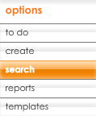

1. If you want to refine results, use the filters. You can click **show more filter options** to see all available filter options



1. All available filter criteria will display, complete the criteria you wish to filter by

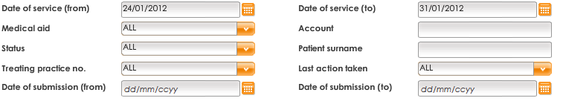

1. Click on **search**



1. All claims matching the criteria will display
2. You can take action on the claim by selecting the appropriate action button



1. Use the navigation options to move between pages



**Alternative search methods**

You can search for claims from the home page; select the **find a claim quick link**

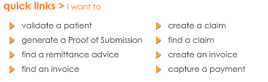

You can search for claims from the **patient** tab; select **search claims** from the **options** menu

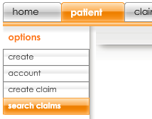

### View claim details

1. Select the claim(s)

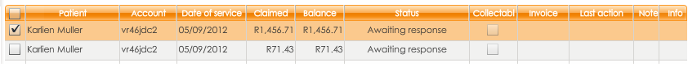

1. To view more details, click on **view**



1. The **claim** tab will be selected automatically, and provides a detailed response on a line-by-line basis, summary response; patient and claim information

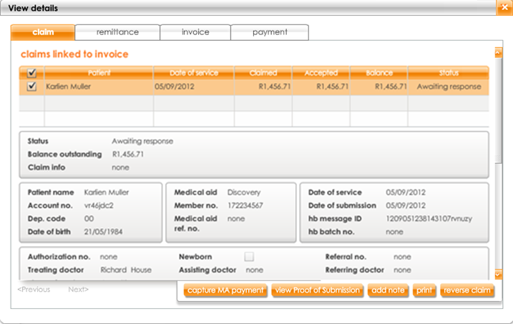

**note**: the **invoice** and **payment** tabs will display any related invoices or payments to the selected claim

1. The **claim details** section provides a detailed response on a line-by-line basis

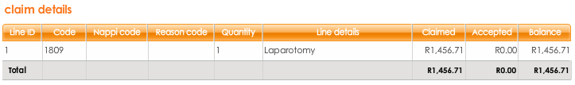

The **medical aid payment details** and **claim action history** are listed below

1. You have the following action buttons available on the claim from this view



1. With the **Processed Claim**, you will immediately receive detailed claim responses that contain financially rich information sent by the medical aid telling you what will or will not be paid
2. If you selected multiple claims, click on **<Previous** and **Next>** to move between claims



#### 

#### Remittance tab

In some instances more than one RA is received for a claim. This is dependent on the medical aids and whether they re-process or process some lines later than others.

To cater for this the remittance details for a claim have been moved – they used to display under the claim details, but now display on a separate **remittance** tab.

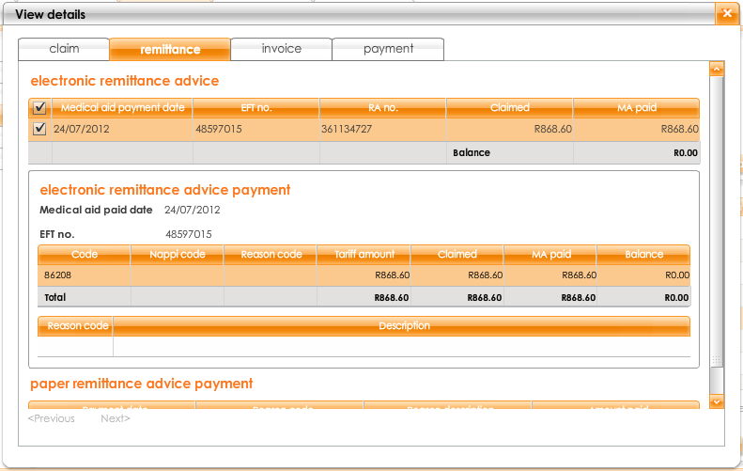

If more than one RA is received they will display one under the other, and if you capture paper RA payment information it will also be visible here.

Also, when a second RA is received for a claim, it will be placed back on the **claims to do list** with the recommended action to **review remittance details.**

### Fix and resubmit a claim

1. View the claim details

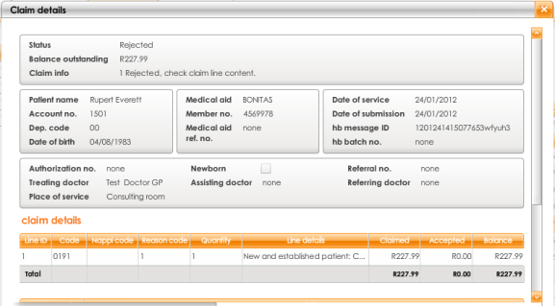

1. Click on **edit claim**



1. Make the necessary changes to the claim – either edit patient, practice or claim line information based on the medical aid response
2. Click on **send claim**



### Reverse a claim

**You can only reverse Discovery Health Processed claims electronically. All other claims have to be manually reversed.**

**Claims with the following statuses can be manually reversed:**

•         Remittance advice received

•         Validated by medical aid

•         Validated by Healthbridge

•         Received by Healthbridge

•         Paid by medical aid

•         Part paid by medical aid

•         Part rejected

#### Discovery Health claim reversals

1. View the claim details

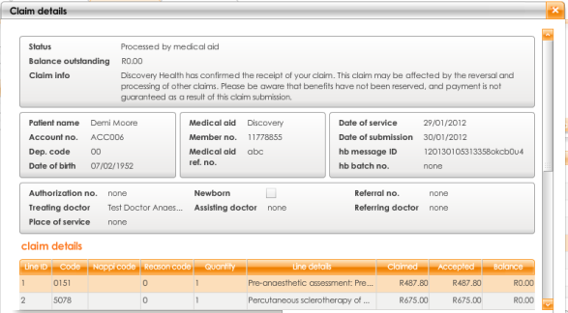

1. Click on **reverse claim**



1. Click on **yes** to confirm

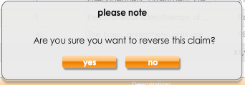

#### Manual claim reversals

1. View the claim details

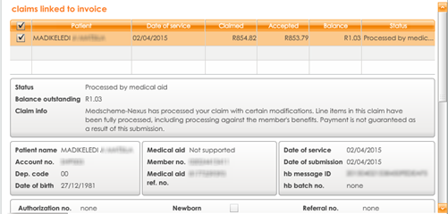

1. Click on **reverse claim**



1. You will be required to contact the medical aid to get approval for your reversal. Once authorisation from the medical aid has been received, click **approved**
2. Enter the reference number from the medical aid for record keeping purposes

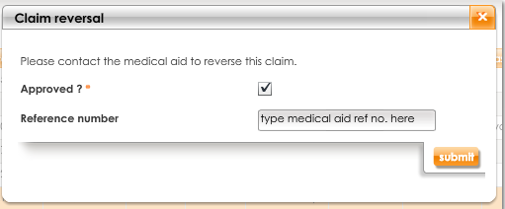

**note**: Claims that have been reversed will no longer display on the **age analysis** of the invoice report and will not be collectible

### Age analysis of claims report

The **age analysis of claims** report provides a summary view of claims over the different ageing periods.

1. Select the **claim** tab



1. Select **reports** and then **age analysis of claims** from the **options** menu

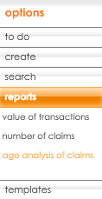

1. Customise the report by changing the filter criteria and clicking **submit**

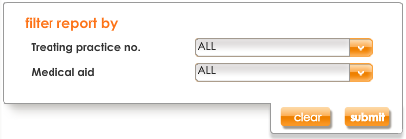

1. The summary view can be seen on the right

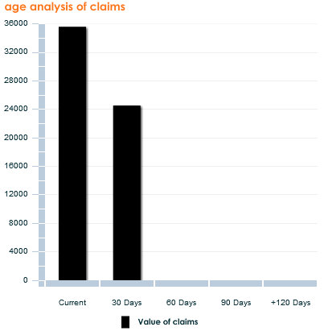

1. You can view the details of this report by clicking **view detail**



1. Click through the tabs to view the details of claims for each ageing period

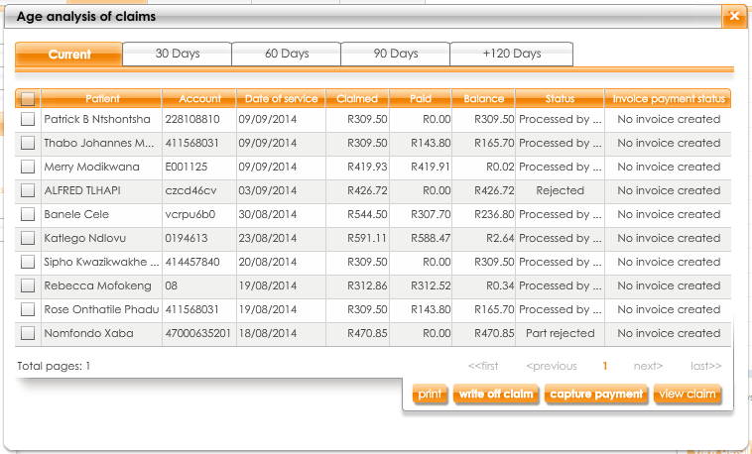

1. You can **print** or **email** this report





# Collections

### What is mypractice with Collections?

We strive to continually improve your experience with our products and services.

We have recognised that collecting outstanding amounts from patients can be a tedious and costly exercise.

Our latest **my**practice release has added functionality to the existing **my**practice. You can now begin to collect from patients from **my**practice.

**my**practice with **Collections** will assist in streamlining your processes for greater admin efficiency.

**Please note:** To make use of the Collections service you need to use the Capture service.

### Getting started – what is new on each tab?

#### The home tab



* Shows your **performance snapshot**
* Provideseasy access to the tools that manage your practice
* DisplaysHealthbridge communications

There is a new item on the **to do list** to follow up on collections.

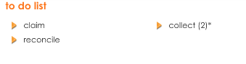

There is also new **quick links** for capturing payments, as well as finding and creating invoices.

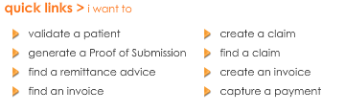

#### The patient tab



* A patient-centric view i.e. looking at one account at a time
* All patient account details, membership details, dependants and contact information is managed here
* A complete view of claims and payments, actions required, and account information at a patient level

You are able to view a **financial summary** for the account as well as **search invoices,** and **search payments**

under the **patient** tab.

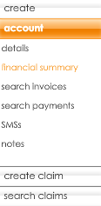

Under the SMS option you have the ability to:

* view an **SMS history**
* send a **new SMS** to the selected patient. The new SMS is free text so you can send any message



#### The claim tab



* A practice-centric view i.e. looking at all the practice’s claims, from various patients
* A complete view of claims and payments, actions required, and account information
* Allows you to work on a specific task, rather than a specific patient
* To reduce the number of steps for those smaller unpaid amounts that you would like to write off, you can now write off directly from the **claim to do list**



#### The reconcile tab



* A complete view of all your remittance advices received
* The place where your RAs are stored for 6 months

You now have access to the **delivery schedule**, which gives you a 3 month view on when to expect electronic remittance advices to be received via **my**practice

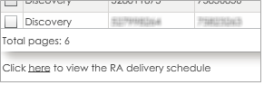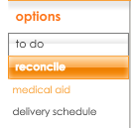

#### The collect tab



* A new tab, allowing you to focus on and work through any invoices generated that may require action
* Allows you to **search for invoices** and **payments** at a practice level and take action, if required
* **Reports** allow you to view:
* Age analysis of invoice
* Invoice detail
* Payment summary
* Payment detail
* Outstanding payments
* Write off report

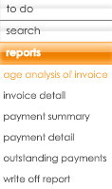

#### The admin tab



* Allows you to customise your **to do list** to recommend **writing off claims below or equal to** the amount inserted
* Customise your SMS settings, including **invoice SMS reminder** times and your **invoice overdue periods**

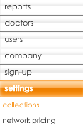

**new**

### Confirm company details

1. Select the **admin** tab



1. Select **company** from the **options** menu

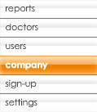

1. Ensure the details required for invoices are complete. These are:

* VAT no.
* Company registration no.
* Physical Address
* Contact details (Office no., Fax no. and email)

1. Click on **save**



### Customise collections settings

1. Select the **admin** tab



1. Select **settings** from the **options** menu
2. Select **collections** from the **settings** menu

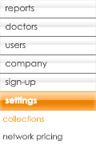

1. **email** will be ticked to enable all invoice delivery and payment methods



The following needs to be set:

* For those small unpaid amounts that you would like to write off, you can set a **claim write off limit**



* Once you have set the claim write off limit, any claim from your **to do list** that has an outstanding balance below the set limit will show the recommended action **write off claim**



* You will still have the ability to write off any claims in your to do list that have other recommended actions. Simply select the claim and click on **write off**



1. The automatic SMS notification settings can be enabled/disabled to suit you

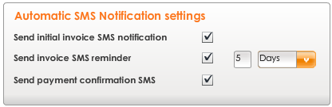

* **Send initial invoice SMS notification** - an SMS to the patient as the invoice is sent. This SMS is only sent the first time the invoice is delivered to the patient
* **Send invoice SMS reminder** - an SMS to the patient after the specified period if no payment has been captured. It is important to capture payments promptly to ensure these SMSs do not go out to patients who have paid
* **Send payment confirmation SMS** - an SMS to the patient immediately after the payment is captured

1. Tick the checkboxes for SMSs you want to enable, or untick to disable
2. You have a bundle of 150 SMS per month included in your monthly subscription. SMSs used once the

bundle is depleted are billed

### Your business process – best practice guidelines

To ensure that you get optimal results, we have recommended some ‘best practices’ to follow during your new collection process:

* An invoice can be created for any claim that has an outstanding balance in **my**practice:
* The **claim is processed** (i.e. you get a real-time response). You will know if anything is owing within minutes of sending the claim
* The **RA is delivered to mypractice electronically**. Once the RA is received the claim status updates to **remittance advice received** and then the outstanding balance will be updated, based on the medical aid response
* The **RA is delivered to you via another channel (e.g. paper or email)**. The claim will remain in accepted status, and you have the ability to capture the payment from the RA into the system

If you do not invoice these claims immediately they will become part of your to do list, to action at a more suitable and convenient time.

* Any Received Claim (with no eRA) or an invoice is only resolved once the outstanding balance is zero
* **Capture your payments to keep accounts up to date; medical aid and patient:**
* Payments reflecting on your bank statement need to be captured in **my**practice
* Cash and POS transactions (debit or credit card) should be captured in real time
* Reconciling must take place regularly; we recommend once a week
* Share the bank statement, or at least the patient payments with your PA if they are responsible for reconciliation

### Workflow – can I invoice this claim?

This workflow will guide you as to whether you can create an invoice for a claim.

Feel free to remove this page from the guide and put it near your PC, easily visible, to help you with the process while it is still new.

Questions to ask are orange, and steps to complete are grey.

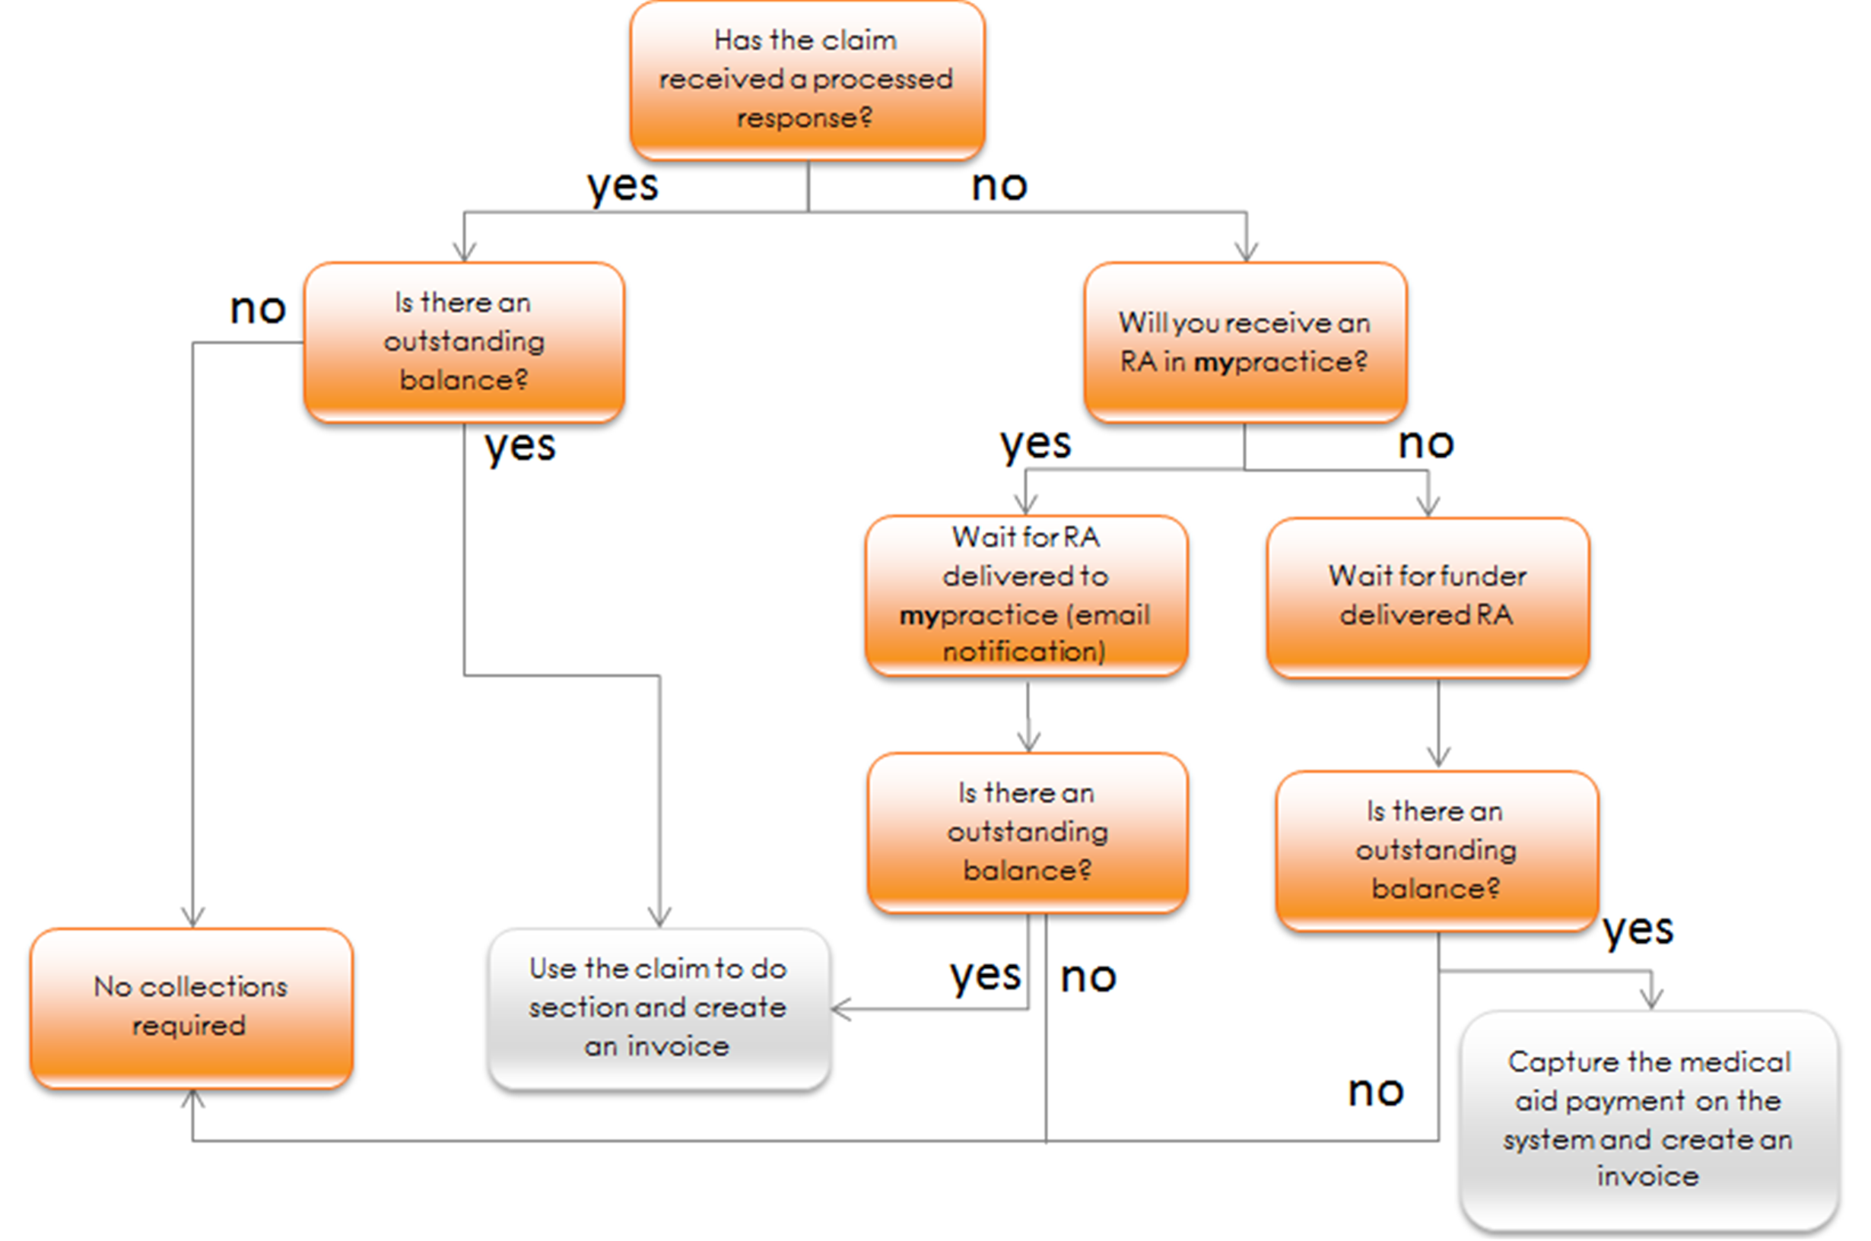

#### Creating an invoice

1. Select the **claim** tab



1. By default you land on **to do**
2. Select the claim you want to create an invoice for
3. Click on **invoice**



1. Choose one of the **invoicing options** (detailed instructions for each option provided on the next few pages)

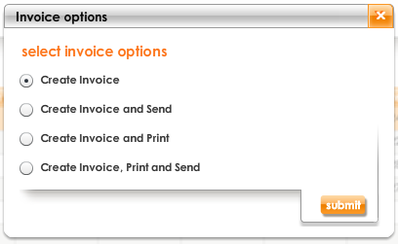

* 1. **Create invoice** – creates the invoice without sending or printing at that moment
  2. **Create invoice and send** – creates the invoice and sends it via email
  3. **Create invoice and print** – creates the invoice and prints it
  4. **Create invoice, print and send** – creates, prints and sends the invoice by email

#### What does the invoice look like?

The invoice is made up of the following information:

* Patient details

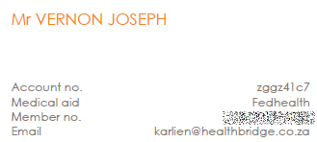

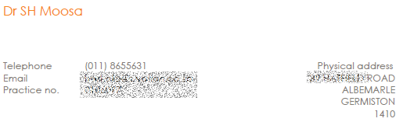

* Practice details
* Invoice items (claims and any additional items), showing what was paid by the medical aid and what the patient is liable for

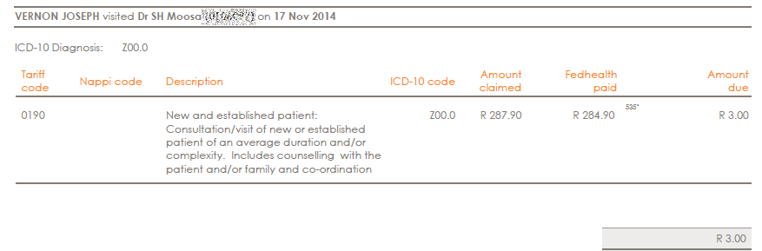

* Detailed medical aid payment information, including reasons



* The doctor’s bank details or pay at your favorite shop

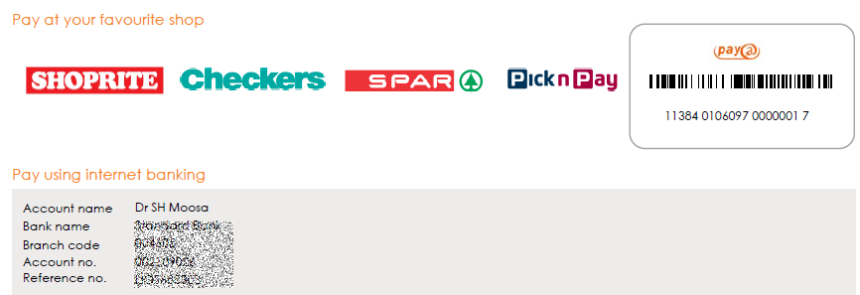

#### a. Create invoice

1. Select **invoice**
2. Click on **submit**



1. The invoiced claim lines will display on screen

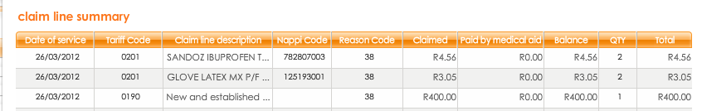

1. You are able to add items to the invoice (levy, consumable, etc.). Complete the relevant details

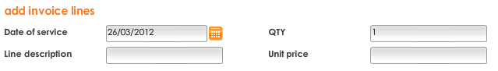

1. Click on **add invoice line**



1. Any saved, additional invoice lines will display in the bottom section
2. You can select and delete any of these lines by clicking on **delete lines**



1. You can edit the additional line, by clicking and changing the line
2. When the invoice is complete, click on **invoice account holder**



#### b. Create invoice and send

1. Select **create invoice and send**
2. Click on **submit**



1. You may add invoice lines as explained in “a. create invoice”, step 4
2. When the invoice is complete, click on **invoice account holder**



1. A summary of the account and patient details are displayed

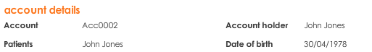

1. Please confirm the **invoice delivery method: email**



1. You are able to add an **invoice message** (optional) e.g. “Thank you for the prompt settlement of your previous invoice.”
2. Confirm that the **contact details** are correct

**note**: If they are incorrect, best practice is also to edit the patient account.   
This ensures that the details are permanently updated

1. Click on **submit**



1. An invoice is sent to the patient, with sufficient details in the body of the message to make payment. The full invoice will be attached

#### c. Create invoice and print

1. Select **create invoice and print**
2. Click on **submit**



1. You may add invoice lines as explained in “create invoice”, step 4
2. When the invoice is complete, click on **invoice account holder**



1. Type an invoice message
2. Click on **print** to confirm

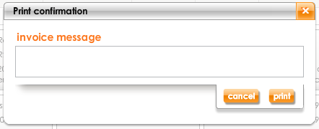

1. A pdf invoice will be created and opened in a new tab or window.   
   You can send this to the printer when ready. Refer to **What does the invoice look like** to see what will   
   be printed

#### d. Create invoice, print and send

1. Select **create invoice, print and send**
2. Click on **submit**



1. You may add invoice lines as explained in “create invoice”, step 4
2. When the invoice is complete, click on **invoice account holder**



1. Please confirm the **invoice delivery method: email**



1. You are able to add an **invoice message** (optional) e.g. “Thank you for the prompt settlement of your previous invoice”
2. Confirm that the **contact details** are correct

**note**: If they are incorrect, best practice is also to edit the patient account.   
This ensures that the details are permanently updated

1. Click on **submit**



1. Type an invoice message
2. Click on **print** to confirm



1. A pdf invoice will be created and opened in a new tab or window. You can send this to the printer when ready

### The collect to do list

This is an online view, showing the last 30 days’ invoices that require action allowing you to easily work through items that require your attention, keeping your tracking current.

1. Select the **collect** tab



1. By default you land on **to do**
2. By default, the last 30 days’ invoices are displayed
3. To change this, adjust the **Date of service (from)**  and **Date of service (to)**



1. To filter by created invoices or part paid invoices select the appropriate drop-down (optional)

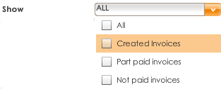

1. Click on **search**



1. Invoices are listed with their required actions, assisting you with more efficient collections tracking
2. Use the navigation options to move between pages



#### Taking action on an invoice

You are able to take action on invoices that have not been paid. The available actions are: **cancel**; **print**; **write off** and **send invoice**

1. Select the invoice
2. Click on the appropriate action button



* 1. **View invoice**: view the selected invoice
  2. **Cancel invoice**: cancel an invoice that has not been sent
  3. **Print**: create a pdf of the selected invoice, to print or save
  4. **Write off invoice**: write off a specific invoice
  5. **Capture payment:** capture payment for a specific invoice
  6. **Send invoice**: send the invoice to the patient, via email or post

1. Follow the prompts to complete the action

**note**: There is an option to send a write off notification SMS to the patient, click **yes** if you want to do so

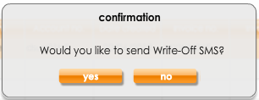

### Search invoices

1. Select the **collect** tab



1. Select **search** from the **options** menu
2. By default, you land on **invoices**

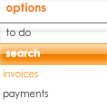

1. If you want to refine results, use the filters
2. All available filter criteria will display, complete the criteria you wish to filter by

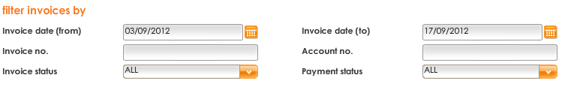

1. Click on **search**



1. All invoices matching the criteria will display
2. You can take action on the claim by selecting the appropriate action button  
   
3. Use the navigation options to move between pages



### View an invoice

1. Search for the invoice(s) you want to view
2. Select the invoice(s)

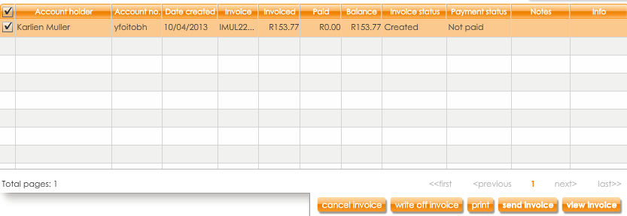

1. Click on **view invoice**



The **invoice** tab will be selected automatically, and provides a summary of the patient’s account details and invoice details

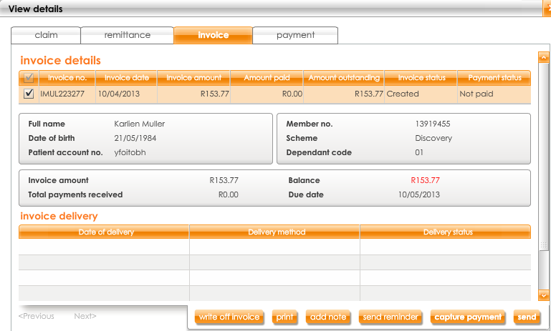

**note**: the **claim** and **payment** tab will display any related invoices or payments to the selected claim

1. The **invoice line details** are listed below

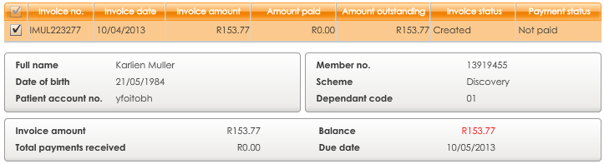

1. You can take action on the claim from this view by clicking the appropriate action button



* **Send reminder** allows you to send an SMS reminder to the patient if they have an invoice outstanding. The reminder reads: ”Reminder: <amount outstanding> is due for visit on <date>. Pay at Shoprite, Checkers, Spar or PnP. Ref. <reference number>. Dr <name>, <contact number>”
* **Capture payment** allows you to capture a payment made for a specific invoice

1. To capture a payment, complete the **payment date, type** and **amount** **received**. You can also enter a **payment** **note** (optional)

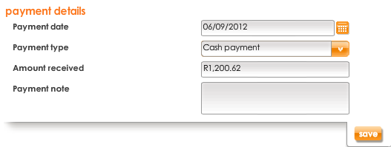

1. Click on **save**



#### Pay@ payments

Patients will be able to make payment for an invoice by taking the invoice to one of the following retailers:

* Shoprite
* Checkers
* Spar
* Pick ‘n Pay

#### Process flow

This process flow will guide you as to how payment takes place using pay@ to when the monies are reflecting in the doctor’s bank account.

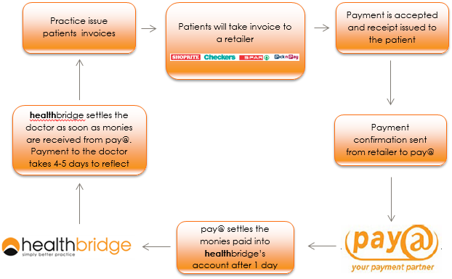

### Search payments

1. Select the **collect** tab



1. Select **search** from the **options** menu
2. Select **payments** from the **search** menu

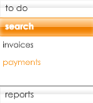

1. If you want to refine results, complete the criteria you wish to filter by

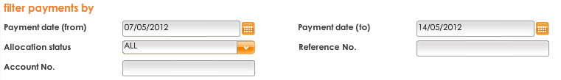

1. Click on **search**



1. All payments matching the criteria will display
2. Use the navigation options to move between pages



#### View a payment

1. Search for the invoice(s) you want to view
2. Select the payment(s)



1. Click on **view payment**



1. The **payment** tab will be selected by default, and provides a summary of the patient’s account details and payment details

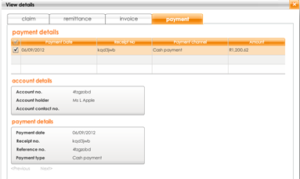

**note**: the **claim** and **payment** tab will display any related invoices or payments to the selected claim

### Reversing payments

Sometimes payment amounts are captured incorrectly, or a patient may claim that payment was made but the amount does not reflect in your bank account. In these cases, payment must be reversed.

1. Search for the payment you would like to reverse
2. Select the payment



1. Click on **view payment**



1. The **payment** tab will display the details of the payment and any other payments for the invoice

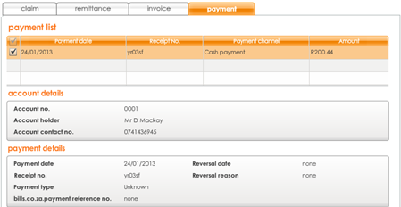

**note**: the **claim**, **remittance** and **invoice** tab will display any related claims, remittance advices and invoices

1. Click on **reverse payment**



1. Confirm the reversal of payment by selecting the relevant reason, then clicking on **yes**

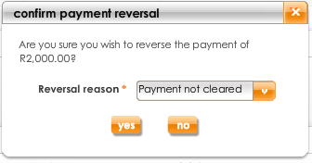

1. Click on **ok**

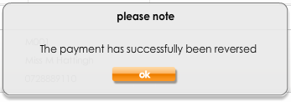

1. The status of the payment changes to reversed



### Capture medical aid payment from paper RA’s

Not all medical aids deliver remittance advices (RAs) to **mypractice.co.za**. Some RAs are still only available on paper or another medium that is not automatically sent to the **my**practice website.

To create invoices for these claims you need to input the RA payment information into **my**practice so that the outstanding amounts can be calculated and an invoice sent.

These claims will have the status **received by Healthbridge**, **validated by Healthbridge** or **received by medical aid** in **my**practice.

To capture a medical aid payment:

1. Select the claim



1. Click on **view**



1. Click on **capture MA payment**



1. Complete the following **payment details**:

* Payment date
* Payment amount   
  *If the claim was not paid in full the following 2 fields are also required:*

Reason code

Reason description (both the description and the reason code are on the RA)

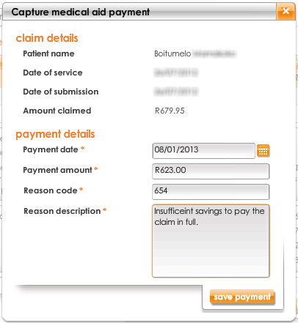

1. Click on **save payment**



1. The claim status will adjust accordingly e.g. **part paid by medical aid** or **paid by medical** **aid** or **processed** (in the event of a zero payment by the medical aid)
2. If an amount is outstanding you will have the option of creating an invoice for the claim, you will then follow the same steps as you would for any other claims

### Reports

1. Select the **collect** tab
2. Select **reports**  from the **options** menu  
   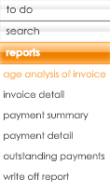
3. There are 6 types of reports that can be viewed, printed or emailed:

**Age analysis of invoice** indicates the aging of invoices with outstanding debts

**Invoice detail** provides you with a more detailed view of the invoices sent within the date range selected

* **Payment summary** provides a summary, at a practice level, of the number and rand value of payments made through different channels. You can adjust the date range to see more, or less, of the payment information
* **Payment detail** provides a detailed list of each payment captured. You can adjust the date range to see more, or less, of the payment information
* **Outstanding payments** provides a list of the number of payments outstanding i.e. you have invoiced the patient but they have not yet paid (or you have not yet captured the payment). You can adjust the date range to see more, or less, of the outstanding payment information
* **Write off report** provides you with the details of any outstanding balances written off within a selected date range. You can filter the dates and view the total amount written off. This report can be used for tax purposes

### Working at a patient level

1. Select the **patient** tab



1. Search for a patient

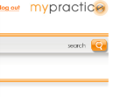

1. If there is an outstanding balance, you will get a pop-up notification, advising you of the outstanding balance
2. Refer to the instructions on the next few pages to see what collection information can be accessed at a patient level

#### Account - financial summary

You will be able to see an overview of the selected patient’s account details, claim summary and invoice summary.

1. Select **account** from the **options** menu
2. Select **financial summary** from the **accounts** menu

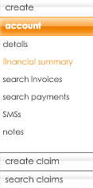

1. If you only want to see the summary over a specific time period you can filter the results

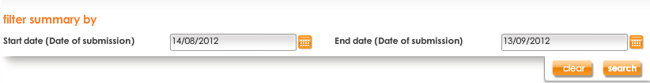

1. The selected patient’s account details will display, at an account level (including main member and dependants)

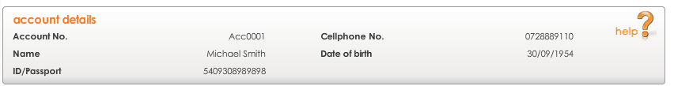

1. A claim summary is provided

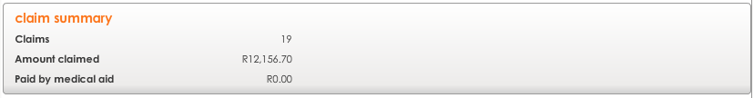

1. An invoice summary is provided

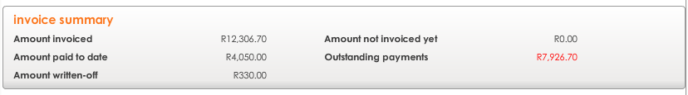

**note**: If there are any amounts that have not been invoiced or any outstanding payments, the figures will appear in red

1. Ageing of outstanding payments are shown as follows



#### Account - search invoices

1. Select **account** from the **options** menu
2. Select **search invoices** from the **accounts** menu

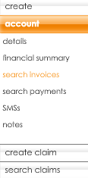

1. If you want to refine results, complete the criteria you wish to filter by

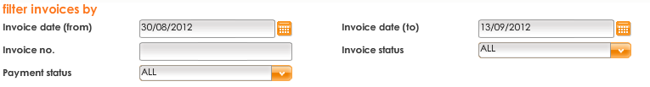

1. Click on **search**
2. All invoices matching the criteria will display
3. You can take action on the invoice by selecting the appropriate action button  
   
4. Use the navigation options to move between pages



#### Account - search payments

1. Select **account** from the **options** menu
2. Select **search payments** from the **accounts** menu

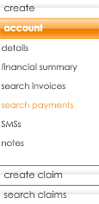

1. If you want to refine results, use the filters
2. Tick **show more filter options** to see all available filter options



1. All available filter criteria will display, complete the criteria you wish to filter by

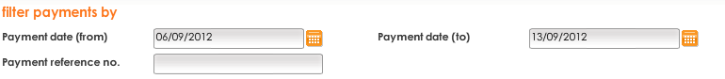

1. Click on **search**



1. All payments matching the criteria will display
2. Click on **view payment** to see payment details



1. Use the navigation options to move between pages



#### Account – SMSs

You are able to view communications sent via SMS by filtering and searching the SMS history.

1. Select **account** from the **options** menu
2. Select **SMSs** from the **accounts** menu

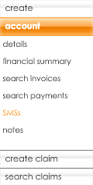

1. If you want to refine results, complete the criteria you wish to filter by

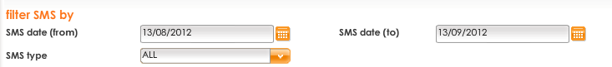

1. Click on **search**



1. All communications matching the criteria will display
2. Use the navigation options to move between pages



#### Creating a new SMS

1. From the **SMSs** screen, click on **new SMS**



1. Manually type in the message you would like to send to the patient
2. Once the message is completed, click on **send**

**note:** The recipient and the cell phone number will be automatically populated for the selected patient

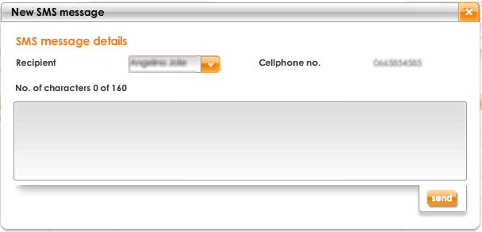

### Practice management features

#### The reconcile to do list

This is an online view, showing the last 30 days’ remittance advices that require action, allowing you to easily work through items that require your attention, keeping your tracking current.

1. Select the **reconcile** tab
2. By default you land on **to do**

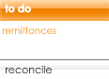

1. By default, the last 30 days’ remittance advices are displayed
2. To change this, adjust the **start** **date** and **end date**



1. Click on **search**



1. RAs are listed with their required actions, assisting you with more efficient reconciliation
2. Use the navigation options to move between pages



#### Remittance advices from the medical aid

1. Select the **reconcile** tab
2. Select **reconcile** from the **options** menu
3. Select **medical aid** from the **reconcile** menu

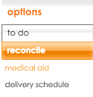

1. If you want to refine results, use the filters
2. Tick **show more filter options** to see all available filter options



1. All available filter criteria will display, complete the criteria you wish to filter by

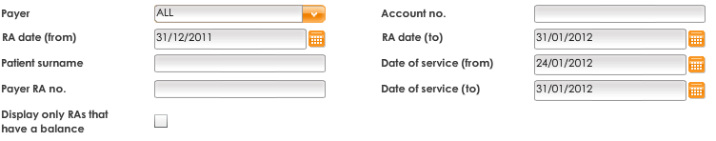

1. Click on **search**



All RAs matching the criteria will display

1. Use the navigation options to move between pages



1. You can choose to print only the unmatched items in an RA when the **number of unmatched** column has a number greater than 0

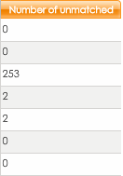

1. To print only the unmatched items in an RA, select the RA and click **print unmatched items** or print the entire RA with matched and unmatched items by clicking **print complete RA**OR 
2. You can select multiple RAs from different funders and print in one document to save paper

#### Reports

1. Select the **admin** tab



1. Select **reports** from the **options** menu

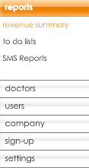

1. Select the report you want to view
2. Adjust criteria, if necessary
3. Click on **submit**



You can view more reports from the **claim** tab; select **reports** from the **options** menu

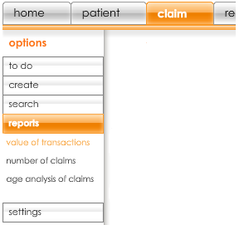

### Support

1. Forgotten username and password – click on **forgot password**

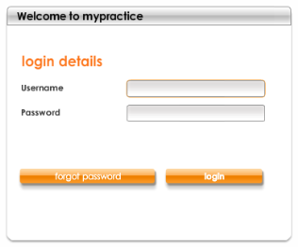

1. Client service centre – **0860 200 222**
2. Client service centre email – **csc@healthbridge.co.za**
3. **my**practice contact us – link on **www.mypractice.co.za**



1. training– **home** tab – **tool & tips** section



1. Your personal client specialist at Healthbridge